Commuters set for a week of Metrolink distruption
Dean Kirby
July 19, 2010
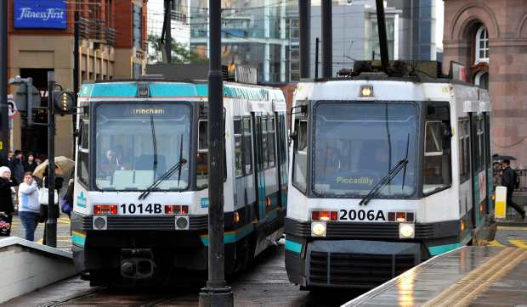
Part of the Bury line will shut from next weekend (July 31) so that it can be connected to the new line to Oldham and Rochdale.
Tram passengers have been told to prepare for a week of disruption because of work to extend the Metrolink network.
Part of the Bury line will shut from next weekend (July 31) so that it can be connected to the new line to Oldham and Rochdale.
Bosses say the work – revealed by the MEN in March – is being done in a week between July 31 and August 6 to avoid more disruption by spreading it over eight weekends.

A report by Greater Manchester Passenger Transport Executive says the week-long shutdown will save £100,000 on the cost of replacement buses.
It means passengers including shoppers travelling to the £350m new shopping complex at The Rock in Bury will have to board replacement buses for part of their journey.
Thousands of people are expected to head into Manchester on August 1 for the mass-participation cycling event, Sky Ride.
Philip Purdy, GMPTE's Metrolink director, said the 'essential' work cannot be done without closing part of the Bury line.
He said: “We do appreciate the closure of a section of the Bury line for the engineering works will cause some disruption.
Essential
“However, the work is essential to the network's expansion and simply cannot be done any other way.
“Rather than dragging out the closure over many weekends, we have opted to condense the closure into a week-long period over the summer to limit inconvenience for passengers.”
A tram 'shuttle' will run between Bury and Woodlands Road and replacement buses will run between Woodlands Road and Piccadilly.
Work will also take place to renew the track crossover at Victoria, which is now almost 20 years old.
It means trams will not run between Victoria and Piccadilly on July 31 and August 1.
Trams on the Altrincham line will terminate at Piccadilly during the weekend, but trams will start running between Piccadilly and Victoria again on August 2.
The Eccles line will be unaffected.
Customer service staff will be at key stops to assist passengers and direct them to replacement buses.
The first section of the Oldham and Rochdale line, from Manchester to Central Park in Newton Heath, will open in spring next year.
It will be extended to Oldham Mumps next autumn and then to Rochdale railway station in spring 2012.

Milestone
Mr Purdy said: “This work represents a significant milestone in the expansion of the Metrolink network.”
He said connecting the Bury line to the new Oldham and Rochdale line was an 'important step' towards opening the first phase of the new route to Central Park next year.
The new line is part of a £600m Metrolink expansion that will see new routes open to Chorlton, MediaCityUK and Droylsden.
The government has also given the green-light for a £170m plan to extend the network to Ashton and Didsbury.
For information on replacement bus services call Metrolink on 0161 244 1555 or visit www.gmpte.com/futuremetrolink .

Source; Manchester Evening News

